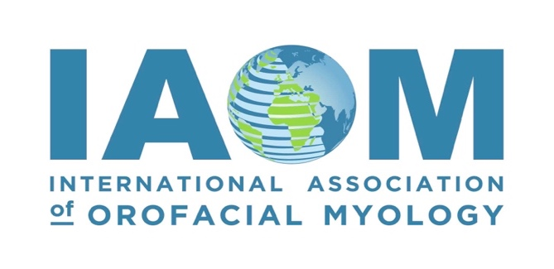

2024 IAOM Convention

Future Vision: Orofacial Myofunctional Innovations

Conference Hotel and Venue Site
Renaissance Raleigh North Hills Hotel at 4100 Main at North Hills Street Raleigh, NC 27609.
* Times, speakers, and rooms subject to change; all times are Eastern Standard Time Zone*

Thursday: September 26, 2024

10:00 am – 6:00 pm Vendor Set-Up
{Location TBD}

4:30 - 6:00 pm Early Registration/Name badge & Swag Bag Pick Up
{Location TBD}

Friday: September 27, 2024

7:00am – 7:45 am Registration & Breakfast

7:45 am – 8:00 am President’s Welcome

8:00 am – 9:30 am Class 1: Donny Mandrawa, BDSc, FICOI, FPFA, FIADFE, PGDip
The Myofocus Take Off Algorithm: First Ever for Orofacial Myofunctional Therapy
1.5 Hours/CEUs

9:30 am – 9:50 am Break, Silent Auction, & Vendors

9:50 am – 11:20 am Class 2: Donny Mandrawa, BDSc, FICOI, FPFA, FIADFE, PGDip
Dropping the E, G, O from Myofunctional Healthcare
1.5 Hours/CEUs

11:20 am – 12:50 pm Class 3: Susan Sheahan, DMD
The Nasal Breathing Revolution with Nitric Oxide
1.5 Hours/CEUs

12:50 pm – 1:50 pm Lunch on Your Own

1:50 pm – 3:20 pm Class 4: Yulli Tamayo-Myerson, RHDT, CMT, OMT, CMA
Biological Laws of Human Biomechanics in Orofacial Myofunctional Therapy
1.5 Hours/CEUs

Friday: September 27, 2024

3:20 pm – 3:40pm Break, Silent Auction, & Vendors

3:40 pm – 5:10 pm Class 5: Yulli Tamayo-Myerson, RHDT, CMT, OMT, CMA
Finding My Balance: "My Myo Ikigai”
1.5 Hours/CEUs

5:30 – 7:30 pm Vendor & Sponsor Cocktail Mixer

Saturday: September 28, 2024
7:00am - 8:00 am Meet the Board of Examiners: Q&A for Certification/COM®

7:00 am - 8:00 am Registration & Breakfast

8:00 am - 9:30 am Class 6 Part A: Soroush Zaghi, MD
A Functional Approach to Sleep & Breathing: Tongue-Tie/Tone & Tongue Space
Must attend Parts A and B for 3.0 Hours/CEUs

9:30 am – 9:50 am Break, Silent Auction, & Vendors

9:50 am – 11:20 am Class 6 Part B: Soroush Zaghi, MD
A Functional Approach to Sleep & Breathing: Tongue-Tie/Tone & Tongue Space (continued)
Must attend Parts A and B for 3.0 Hours/CEUs

` 11:20 am – 11:30 am Quick Break & Set up for Next Speaker

11:30 am – 12:30 pm Class 7: Nora Ghodousi-Zaghi, DDS
Enhancing Pediatric Airway Health: The Role of Dental Interventions
1.0 Hour/CEU

12:30 pm – 1:30 pm Lunch on Own

1:30 pm – 3:00 pm Class 8 Part A: Rehab Zaytoun, MD, Vanessa Anderson-Smith, MA, CCC-SLP, COM® and Monica Marie Purdy, MA, CCC-SLP, COM®
Cultural Competence, Humility, and Responsiveness in Myofunctional Therapy
Must attend Parts A and B for 3.0 Hours/CEUs
*(See DEI information below ASHA Brand block)

3:00 pm – 3:20 pm Break, Silent Auction, & Vendors

3:20 pm -4:50 pm Class 8 Part B: Rehab Zaytoun, MD, Vanessa Anderson-Smith, MA, CCC-SLP, COM® and Monica Marie Purdy, MA, CCC-SLP, COM®
Cultural Competence, Humility, and Responsiveness in Myofunctional Therapy (continued)
Must attend Parts A and B for 3.0 Hours/CEUs
*(See DEI information below ASHA Brand block)

Sunday: September 29, 2024

7:00 am - 8:00 am Registration & Breakfast

8:00 am – 9:30 am Class 9: Shifa Shamsudeen, MDS, D. ABDSM
Is Prevention of Obstructive Sleep Apnea Possible?
1.5 Hours/CEUs

9:30 am – 9:50 am Break & Vendors

9:50am – 11:20 am Class 10: Nicole Archambault, EdS, MS, CCC-SLP, CYMHS, CSSC
The Heart of the Pivot: Moving Children & Families Beyond the Airway
1.5 Hours/CEUs

11:20 am – 12:20 pm Lunch on Your Own

12:20 pm – 2:20 pm Class 11: Christine M. Nguyen, OTD, OTR/L, SWC, Licensed Occupational Therapist
How Tethered Oral Tissues Can Impact Sleeping, Breathing, and Feeding
2.0 Hours/CEUs

2:20 pm – 2:30 pm Break & Vendors

2:30 pm – 4:00 pm Class 12: Nancy Pearl Solomon, PhD, CCC-SLP; Harrison N. Jones, PhD, CCC-SLP
Myofunctional Approaches to the Treatment of Obstructive Sleep Apnea
1.5 Hours/CEUs

4:00 pm – 5:00 pm IAOM End of Year Business Meeting Review & Closing Results

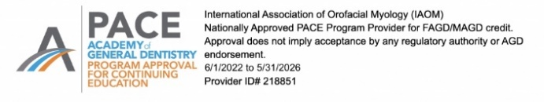
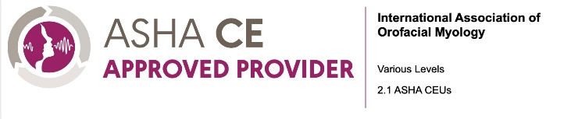
The DEI session is offered separately for 0.3 ASHA CEUs, various levels.
All sessions, excluding the DEI session, are offered for up to 1.8 ASHA CEUs, various levels.
The entire conference is offered for up to 2.1 ASHA CEUs, various levels.

