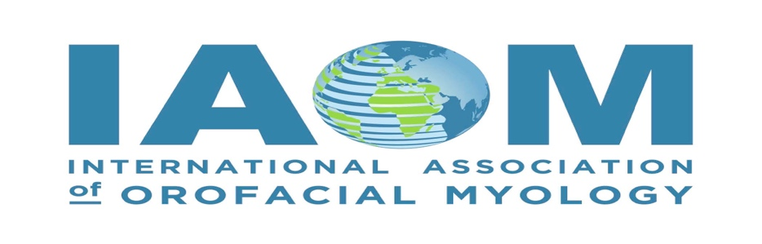

Professional Code of Conduct for IAOM Conference

Course: Rounding up a Collaborative Team for the Orofacial Myofunctional Community
Date: October 13, 14, 15, 2023
Location: Chandler, Arizona USA

My consent on the following conference registration form and submitting payment online indicates that I agree to the following terms:

1. Refunds are available in part until 8/31. From 9/1 onward no refunds are available once I’m registered for the conference event. Special requests can be submitted for review but not guaranteed in any refund. See submission process below.

2. Non-Disclosure/Agreement to Protect Course Content: My acknowledgement of checking the Professional Code of Conduct for IAOM Conference indicates that I agree to and understand that:
  - As a course participant, I acknowledge that the course materials, including but not
limited to digital, audiovisual, and print are copyrighted and I agree not to share, transmit, or reproduce any course materials without the express permission of the International Association of Orofacial Myology (IAOM) and/or from the course presenter themselves.
  - Course content may include confidential client information, and course participants
may ask questions or offer information about their own personal, professional, or clinical situations and as a participant I am to uphold the privacy of such disclosures and will refrain from sharing any and/or all content
  - I am not able to audio, video, or by any other means screen capture or record
any content of this course, including for my own personal use
3. Course Participation. I agree to the following:
- I will not abuse, harass, intimidate, judge, shame, embarrass or otherwise cause
concern with other participants during group or question and answer sessions, and will honor that all participants want a mutually beneficial online learning environment
b. I will not post or transmit any obscene, offensive, libelous, defamatory, pornographic,
or abusive content, or any content that infringes on the intellectual property rights of others
c. I will not use the online event platform in any way to post or transmit spam,
unwanted or unsolicited content, nor will I in any way attempt to promote or sell my own content, services, or products to anyone else during the course.
d. I agree to keep all interactions, communications, attendance, and participant
information private.
e. I will not share my course log-in or password information to any other person for any purpose
and will keep it private and confidential for only my use.

I understand all the above as stated and that any failure to abide by these rules can be cause for immediate dismissal from the conference event and any CEUs that I submitted may be revoked.

Cancellation, Refund Policy, and Complaint Resolution
Cancellation:
In the event of the organization (IAOM) cancelling the conference event, the organization will notify each registered participant on the cancellation. Communication will be provided to the course participant with the email address used for registration. It is up to the organization to deem how to transfer monies/payment received towards a rescheduled event in its place and/or by issuing a full refund.

Refund Policy:

Refunds are available in part until 8/31. From 9/1 onward no refunds are available once registered for the conference event. Special requests can be submitted for review but not guaranteed in any refund.
To apply for a special request/exemption, please email the Executive Coordinator at: info@iaom.com your request and reason for refund. The Executive Coordinator will take your special request for refund to the Executive Committee, for further review. Please ensure you provide the Executive Coordinator any documentation necessary for the Executive Committee to review with your email request. There is no guarantee that you will receive a refund.

Complaint Resolution:

As a conference participant you will have the opportunity to evaluate each speaker that you attend for feedback. The speaker evaluations will go directly to the speaker that presented along with the IAOM Education Committee, Convention Committee and Board of Directors who will review each speaker evaluation. The same will hold true for an overall evaluation and feedback form on the conference event.

The IAOM appreciates constructive feedback in order to improve future speakers, platforms and delivery methods in education and continuing education units for those that attend. This helps in the planning process for future speakers, topics, location(s), and course content.

The IAOM is a volunteer run Non-Profit. If you are a member of the Non-Profit and wish to get involved, please email the Executive Coordinator at info@iaom.com how you can volunteer, contribute, and help improve future program events.

